Storyboard

Group Members :

Something about Car model

Types of Models

* 718 Cayman
* 718 Boxster
* 718 Cayman GTS
* 911 Carrera
* 911 Carrera GTS
* 911 Turbo

Introduction about the Brand

In 2006 it won the most prestigious automobile brand for over 70 years of excellence and dedication to the four-wheel god. Porsche is a renowned automobile manufacturer that specializes mainly in producing sports cars. The German automobile maker has succeeded in producing sports cars that are known for performance, quality, and reliability. Above all, the Porsche is popular for producing prestigious sports cars that can be used for everyday driving

Car Pictures

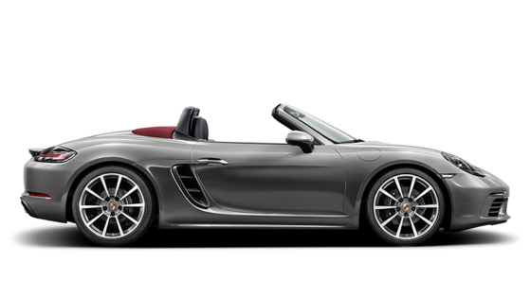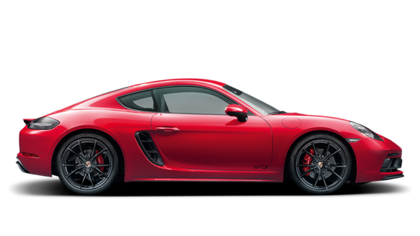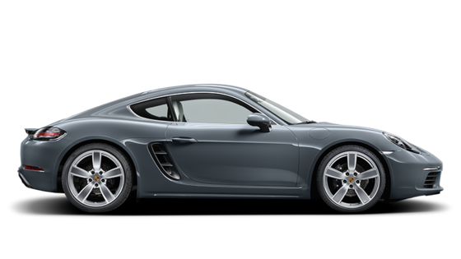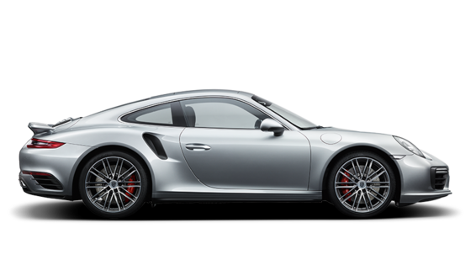

Something about Car Accessories

Porsche expresses personal freedom and individuality in personalizing our vehicles. Inspired by the first Roadster, Porsche introduces Tequipment. Porsche Tequipment allows you to assert your own individuality and creativity; Tequipment range of components offers an almost unlimited scope for personalizing your very own Porsche.

Group’s members’ individual picture

Feedback form

Can be viewed from original website

